WEEK 1 TASK
Planning & Requirements Analysis
for an E-Governance Digital Service
Project Plan and Requirements Specification
Prepared for: Yuvaintern
Prepared By: Sawan Rawal
College/University: Nanhi Pari Seemant Engineering Institute of Technology, Pithoragarh, Uttarakhand
Internship/Company: Yuvaintern
Mentor/Supervisor: Not Provided
Internship Role: Junior Web Developer
Week: 1

1. Executive Summary
This document presents a practical plan for a citizen-centred e-governance digital service platform. The proposed platform provides a single web entry point where citizens can discover public services, register or authenticate, submit applications, upload supporting documents, track progress, receive notifications, and obtain a final decision or digital document. Government staff receive a role-based administrative workspace for verification, workflow management, communication, reporting and audit.
The planning approach is informed by publicly available examples, especially India's DigiLocker and UMANG, and by World Bank guidance on digital public infrastructure. DigiLocker demonstrates the value of consent-based document exchange, real-time verification, strong authentication and auditability, while World Bank research highlights fragmentation, interoperability, privacy, cybersecurity and digital inclusion as major public-service challenges. These lessons are translated into requirements for the proposed platform.
The recommended first release should focus on a small number of high-value services rather than attempting to digitize every government process at once. The architecture should be modular so additional departments and services can be integrated later.

2. Project Overview

2.1 Proposed Project
Working name: CitizenConnect — E-Governance Digital Service Platform
CitizenConnect is a responsive web platform designed to simplify access to public services. The platform is intended as a reference architecture and project plan, not a replacement for any existing government system. It can be adapted for a state department, municipal body, university/public institution, or multi-department service centre.

2.2 Vision
To make public services simple, transparent, secure and accessible through a user-centred digital experience.

2.3 Problem Statement
Citizens may need to navigate multiple websites, submit similar information repeatedly, visit offices for status updates, and provide paper documents for verification. Public digital services can also suffer from fragmented systems, poor interoperability, privacy risks and unequal access. The World Bank specifically notes that digital services are often fragmented and difficult to navigate, while weak governance, privacy and cybersecurity protections can reduce trust.

2.4 Proposed Solution
Create a unified service portal with a common citizen account, searchable service catalogue, guided application forms, document upload/verification, application tracking, notifications, help/grievance support and a secure department dashboard.

3. Research and Benchmark Analysis

3.1 DigiLocker — Key Lessons
DigiLocker is a flagship Digital India initiative of MeitY that provides citizens with access to authentic digital documents. Its public documentation highlights consent-based sharing, real-time verification, access rights management, two-factor authentication, encryption, logging, digital signatures and interoperable APIs. Its current public site reports more than 70 crore registered users and more than 900 crore issued documents (figures displayed on the site in August 2026).
Planning lessons: use explicit consent, minimize repeated document submission, maintain audit logs, design for interoperability, and make document verification easy for authorized departments.

3.2 UMANG — Key Lessons
UMANG is a Digital India project designed to provide access to many government services and schemes in one place. This supports the principle that citizens should not have to understand departmental boundaries before finding a service.
Planning lessons: provide one service catalogue, clear categories, consistent navigation, mobile-first access and a common experience across departments.

3.3 World Bank — Digital Public Service Lessons
World Bank guidance identifies digital identity, digital payments and trusted data sharing as important building blocks of digital public infrastructure. It also highlights fragmentation, interoperability, privacy, cybersecurity and digital exclusion as risks that must be addressed from the beginning.

3.4 Benchmark Summary
Platform / Source | Observed Strength | Lesson for Proposed System | Risk to Watch
DigiLocker | Secure document access and verification | Consent, verification, audit logs, interoperability | Privacy and unauthorized access
UMANG | Many services in one place | Unified catalogue and consistent UX | Complex navigation at large scale
World Bank guidance | Trusted, inclusive DPI | Security, inclusion and interoperability by design | Digital divide and fragmented systems

4. Project Goals and Objectives
- Provide a single, simple entry point for selected public services.
- Reduce manual paperwork and unnecessary office visits.
- Give citizens transparent application status and reference numbers.
- Enable departments to manage cases through role-based workflows.
- Protect personal data through least-privilege access, encryption and audit logging.
- Support mobile devices, accessibility features and low-bandwidth use.
- Create an integration-ready architecture for identity, payments, document verification and notifications.
- Measure service performance using transparent operational metrics.

5. Scope

5.1 In Scope — MVP
- Citizen registration/login and profile management.
- Searchable service catalogue and service detail pages.
- Guided online application forms with validation.
- Document upload and document metadata.
- Application reference number and status tracking.
- Department staff dashboard with role-based access.
- Notifications through email/SMS-ready integration points.
- Help, FAQ and grievance/feedback submission.
- Audit trail for important administrative actions.
- Basic reporting: applications received, pending, completed and average processing time.

5.2 Out of Scope for Initial Release
- Replacing national identity infrastructure.
- Building a nationwide payment network.
- Digitizing every government department at once.
- Fully automated decision-making for sensitive public benefits.
- Storing unnecessary identity data when a verification response is sufficient.

6. Stakeholder Analysis
Stakeholder | Needs | Influence | Key Concerns | Engagement
Citizens | Simple service, status, notifications, accessibility | High | Privacy, ease of use, delays | Usability testing, surveys, support
Department staff | Queue, verification, workflow, case history | High | Workload, training, accuracy | Workshops, pilot, training
Department managers | Reports, SLAs, bottlenecks | High | Performance, accountability | Dashboards, monthly reviews
IT / Security team | Reliable architecture, monitoring, controls | High | Cybersecurity, uptime, integration | Architecture reviews, audits
Policy / Legal team | Compliance, consent, records | High | Data protection, retention | Requirements and policy review
Service partners | APIs, verification, notifications | Medium | Interoperability, contracts | Technical integration planning
Support/helpdesk | Ticket handling and FAQs | Medium | Clear escalation process | Training and feedback loop

7. User Personas

Persona A — Citizen Applicant
A citizen using a phone to apply for a certificate/service. Limited time and may have average digital skills.
Primary needs: Find service quickly, understand requirements, submit once, track status without visiting an office.

Persona B — Department Officer
An authorized staff member reviewing applications and supporting documents.
Primary needs: See assigned cases, verify information, request corrections, approve/reject according to policy and maintain records.

Persona C — Department Manager
A supervisor responsible for service performance.
Primary needs: Monitor workload, processing time, pending cases, SLA breaches and staff performance.

Persona D — Support Agent
A helpdesk user assisting citizens with login, application and status problems.
Primary needs: Search cases safely, answer FAQs, record tickets and escalate issues without seeing unnecessary sensitive data.

8. Functional Requirements
ID | Requirement | Description
FR-01 | Account and authentication | Users can register, sign in, sign out and recover access using an approved authentication method.
FR-02 | Service discovery | Users can search, filter and browse services by department/category.
FR-03 | Service information | Each service displays eligibility, required documents, fees if applicable, expected processing time and contact/help information.
FR-04 | Application form | Users can enter information through structured forms with client/server validation.
FR-05 | Document handling | Users can upload permitted files, see document status and replace invalid documents.
FR-06 | Review and consent | Before submission, the user can review entered information and confirm required consent/attestation.
FR-07 | Application tracking | Each submitted application receives a unique reference number and status history.
FR-08 | Officer workflow | Authorized officers can claim/assign cases, review information, request corrections and record decisions.
FR-09 | Notifications | The system can trigger email/SMS/in-app notifications for important status changes.
FR-10 | Grievance/support | Users can raise a support request and receive a ticket/reference number.
FR-11 | Administration | Admins can manage users, roles, services, workflow settings and non-sensitive content.
FR-12 | Audit logging | Security-relevant and workflow actions are logged with timestamp, actor and action.
FR-13 | Reporting | Managers can view operational reports and export permitted aggregated data.

9. Non-Functional Requirements
Quality Attribute | Requirement
Security | Encryption in transit and at rest where appropriate; MFA for privileged users; RBAC; secure session handling; audit logging; secure secrets management.
Privacy | Collect only necessary data; define purpose, consent, retention and deletion rules; restrict staff access by role.
Availability | Target high availability for production; define backup, disaster recovery and incident response procedures.
Performance | Common pages should load quickly on normal mobile connections; APIs should use pagination, caching where safe and efficient database queries.
Accessibility | Follow WCAG-oriented practices: keyboard navigation, readable contrast, labels, alternative text, scalable text and screen-reader-friendly structure.
Usability | Plain language, consistent navigation, progress indicators, clear errors and minimal repeated data entry.
Scalability | Modular services and APIs so additional departments and services can be added without redesigning the whole system.
Interoperability | Use documented REST APIs and standard machine-readable formats such as JSON; design integration boundaries for trusted external systems.
Maintainability | Version-controlled code, coding standards, automated testing, documentation and CI/CD.
Auditability | Important actions must be traceable without exposing unnecessary personal data in logs.

10. Proposed Technical Strategy

10.1 Recommended Technology Stack
Layer | Technology | Purpose
Frontend | HTML5, CSS3, JavaScript/TypeScript, React or another component-based framework | Responsive citizen and staff interfaces
Backend | Node.js + Express or NestJS | REST APIs, authentication, workflow and integrations
Database | PostgreSQL | Relational data, transactions and reporting
File/Object Storage | S3-compatible object storage | Controlled storage of uploaded documents
Authentication | OIDC/OAuth 2.0-compatible identity layer; MFA for privileged accounts | Secure authentication and delegated access
Notifications | Email/SMS provider via service adapter | Status updates and alerts
Deployment | Cloud platform with managed database and HTTPS | Scalable and maintainable hosting
DevOps | Git, CI/CD, automated tests, environment-based configuration | Repeatable releases
Monitoring | Centralized logs, metrics and alerts | Reliability and incident response

10.2 High-Level Architecture
The platform should use a layered architecture: presentation layer, API/business layer, data layer and integration layer. Authentication, authorization, logging and monitoring should be cross-cutting concerns.
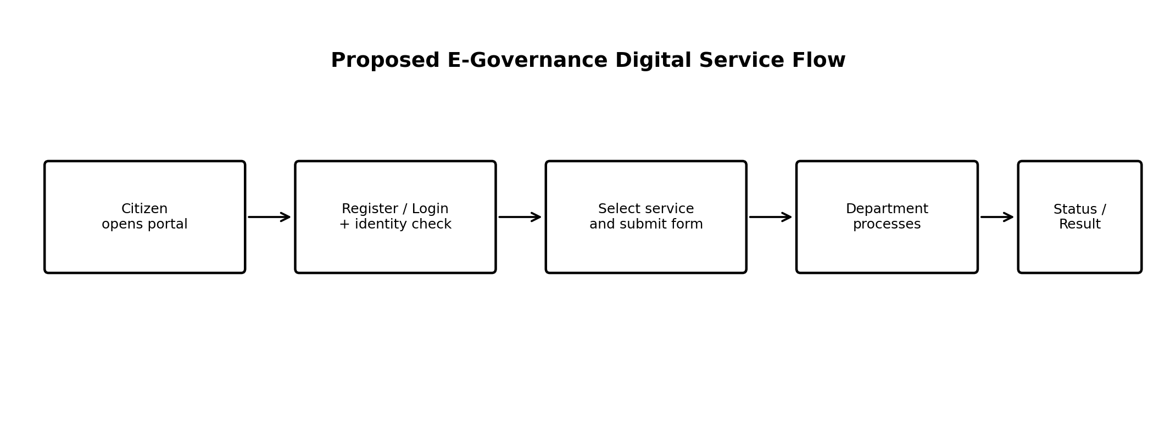
Figure 1. Proposed citizen-to-department service flow.

10.3 Core Data Entities
- User: user_id, contact details, authentication reference, status, created_at.
- Role: role_id, role_name, permissions.
- Service: service_id, name, department, eligibility, SLA, active status.
- Application: application_id, reference_number, user_id, service_id, status, submitted_at, updated_at.
- Document: document_id, application_id, document_type, storage_reference, verification_status.
- WorkflowEvent: event_id, application_id, actor_id, event_type, timestamp, remarks.
- Notification: notification_id, user_id/application_id, channel, template, delivery_status, timestamp.
- SupportTicket: ticket_id, user_id, category, priority, status, assigned_to.

11. User Journey Map
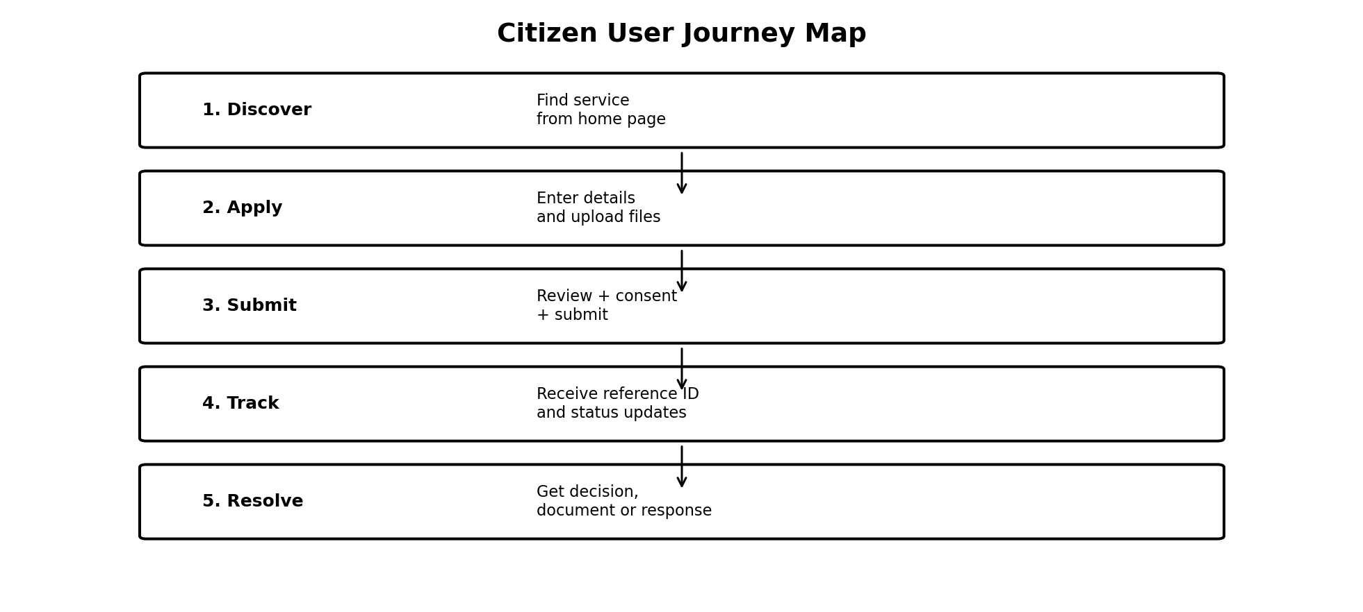
Figure 2. Proposed citizen journey from discovery to resolution.
The journey should minimize uncertainty. At every stage, the user should know what to do next, what information is required, whether the action succeeded, and how to get help.

12. Initial Wireframe Concept
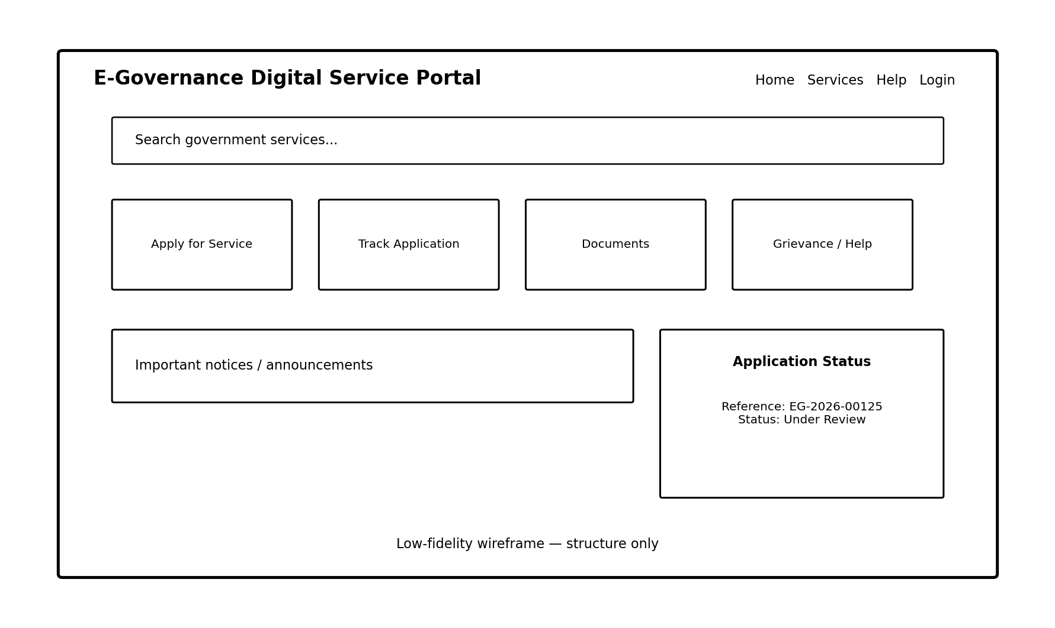
Figure 3. Low-fidelity homepage/dashboard wireframe.
- Header: government identity, language/accessibility controls, help and login.
- Search: prominent service search to reduce navigation burden.
- Service cards: high-value actions such as applying, tracking, documents and support.
- Status panel: quick access to active applications.
- Announcements: time-sensitive public notices.
- Mobile layout: cards should stack vertically and forms should remain usable on small screens.

13. Risk Analysis
Risk | Likelihood | Impact | Mitigation | Owner
Data breach / unauthorized access | Medium | Very High | MFA for privileged roles, least privilege, encryption, secure coding, audits, monitoring | Security/IT
Low digital literacy | High | High | Plain language, guided forms, accessibility, assisted-service/helpdesk options | Product/UX
System downtime | Medium | High | Monitoring, backups, redundancy, tested recovery plan | IT/DevOps
Integration failure | Medium | High | API contracts, sandbox testing, retries, clear error handling | Technical Lead
Poor adoption by staff | Medium | Medium | Early workshops, training, pilot and feedback loop | Project Manager
Incorrect or duplicate data | Medium | High | Validation, unique references, controlled edits, reconciliation | Product/IT
Scope creep | High | Medium | MVP boundary, change-control process, prioritized backlog | Project Manager
Vendor/cloud dependency | Medium | Medium | Documented interfaces, backups, portability plan | Architecture/IT
Accessibility gaps | Medium | High | Accessibility acceptance criteria and user testing | UX/QA

14. Proposed Project Timeline
Phase | Duration | Main Activities | Deliverables
Week 1 — Planning | 1 week | Research, stakeholder analysis, personas, requirements, scope | This project plan + wireframes
Week 2 — UX & Architecture | 1 week | User flows, database model, API design, security baseline | UI prototype + architecture spec
Weeks 3–4 — MVP Build | 2 weeks | Authentication, service catalogue, forms, applications, dashboard | Working MVP
Week 5 — Integrations | 1 week | Notifications, document handling, external service adapters | Integrated MVP
Week 6 — Testing | 1 week | Functional, security, accessibility, performance and UAT | Test report + fixes
Week 7 — Deployment | 1 week | Production configuration, monitoring, backups, documentation | Production release

15. MVP Acceptance Criteria
- A new citizen can find a selected service in three or fewer primary navigation steps.
- A citizen can complete and submit an application with server-side validation.
- The system generates a unique application reference number.
- The citizen can view current status and previous workflow events that are safe to disclose.
- An authorized officer can review and update a case according to the configured workflow.
- Role permissions prevent ordinary citizens from accessing officer/admin functions.
- Important workflow actions create audit records.
- The interface is usable on a current desktop browser and a mobile screen.
- Critical security controls are tested before production release.
- Backup and recovery procedures are documented and tested.

16. Success Metrics and KPIs
- Service completion rate: percentage of started applications successfully submitted.
- Average processing time: time from submission to final decision.
- SLA compliance: percentage completed within the published target.
- Digital adoption: percentage of eligible transactions completed online.
- Drop-off rate: percentage abandoning forms at each major step.
- Support rate: number of support tickets per 100 applications.
- System availability and API error rate.
- Accessibility defect count and usability-test success rate.
- Citizen satisfaction score after service completion.

17. Security and Privacy by Design
- Apply least-privilege RBAC so users and staff see only what they need.
- Use HTTPS/TLS for all network communication and secure password/authentication practices.
- Protect secrets using environment/secret management rather than source code.
- Use MFA for administrators and other privileged users.
- Validate and sanitize all user input on the server; protect against common web vulnerabilities.
- Encrypt sensitive stored data where appropriate and restrict database access.
- Maintain tamper-resistant audit logs and monitor suspicious activity.
- Define data retention and deletion rules before production launch.
- Use explicit consent for data sharing when consent is the legal basis and record the relevant event.
- Conduct security testing before release and after major changes.

18. Accessibility and Digital Inclusion
The platform should not assume that every citizen has a fast connection, a modern device, high digital literacy or a disability-free user experience. The design should therefore support responsive layouts, clear language, keyboard navigation, readable text, accessible forms, multilingual content where required, visible error messages and a help/assisted-service route.
Digital inclusion should be treated as a functional requirement rather than an optional design enhancement. Where the service is legally or operationally critical, offline/assisted alternatives should be planned so that digitization does not unintentionally exclude citizens.

19. Conclusion
The proposed CitizenConnect platform provides a realistic starting point for an e-governance digital service. Its main principle is to design around the citizen's task rather than around government departmental structure. The project should begin with a controlled MVP, validate the workflow with real users and department staff, and then expand through modular services and secure integrations.
The strongest lessons from public digital-service examples are: simplify discovery, minimize repeated paperwork, make status transparent, build trust through security and consent, maintain interoperability, and design for inclusion. These principles provide a practical roadmap from requirements analysis to a deployable digital public service.

20. Publicly Available References
- DigiLocker — About DigiLocker: https://www.digilocker.gov.in/web/about/about-digilocker
- DigiLocker — Technology Overview: https://www.digilocker.gov.in/web/technology
- DigiLocker — Architecture: https://www.digilocker.gov.in/web/architecture
- DigiLocker — FAQ: https://www.digilocker.gov.in/web/about/faq
- UMANG — Services: https://web.umang.gov.in/landing/services
- World Bank — Digital Public Infrastructure and Services: https://www.worldbank.org/ext/en/topic/digital-and-ai/digital-public-infrastructure-and-services
- World Bank — Digital Government: https://www.worldbank.org/en/brief/2025/04/10/digital-government
- World Bank — Digital Society: https://www.worldbank.org/en/brief/2025/04/10/digital-society

Appendix A — Suggested Backlog for the Next Sprint
- Create information architecture and service catalogue taxonomy.
- Create clickable prototype for citizen application flow.
- Define API endpoints for authentication, services, applications and documents.
- Create database ERD and migration scripts.
- Define role-permission matrix.
- Prepare security threat model and data-flow diagram.
- Select one pilot service and document its complete business process.
- Create test cases from each functional requirement.
- Set up Git repository, issue tracker and CI pipeline.

